NEWSLETTER
DECEMBER 2018

If you haven’t already seen it, there is a list of items needed for the Luxury Christmas Hamper on the board outside the play room. We also usually have bottles of booze and a paired up item (eg. Bottle of Whisky & Christmas cake), these will also be on the list. If you could donate something please cross the item off the list and put your name alongside. If you would like to donate other items that we could use in the raffle, such as chocolates, toiletries etc. that we can make up into baskets, or you have any baskets we could use for this purpose please bring them in or give them to the escort if your child comes on transport.
10 books of raffle tickets have now been issued to each child, please try your best to sell as many as you can.

The children’s Christmas Parties are as follows

Baby/Tweeny party will be on Thursday 6th December at the usual time. Father Christmas will be in attendance. This will be the last Baby session until we return in January 2019.

We are having 2 Play session parties, this is to reduce the number of children at each party. The parties are on 13th December at Bolton Garden Centre, Wigan Rd. The morning party will be from 10am – 11.30am and the afternoon party will be from 1pm – 2.30pm. Father Christmas will be attending. Parents are welcome.

Our last session for children will be Wednesday 19th December we re-open on January 7th 2019.

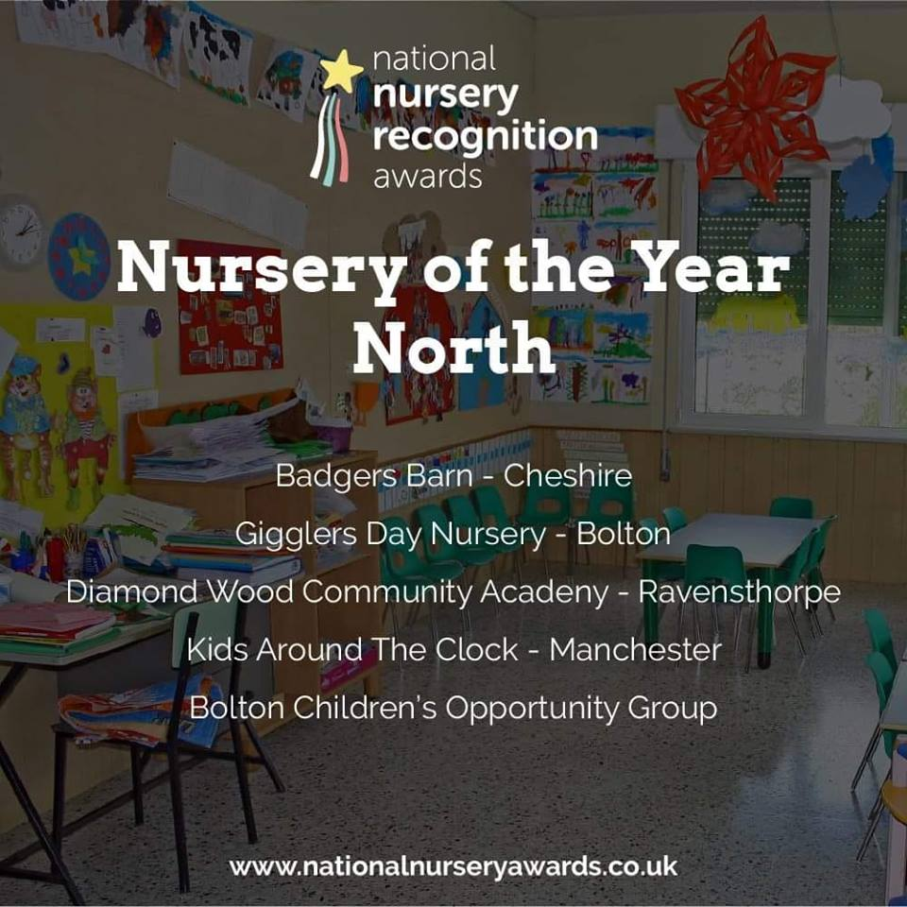

WE NEED YOU TO VOTE FOR US
Please visit the website
www.nationalnurseryawards.co.uk
In the menu click on vote, find us in the North section and click on us, then scroll to the bottom of the voting page, enter your email then click submit vote.
If you are on Facebook and have not already done so, please share the link and get all your friends to do the same. Don’t forget to ask them to vote.
Voting is open until 6th January 2019 so there is still time to vote.

St James’ Place Charitable Foundation
£2500.00¹
Phil Arlott £50.00¹
BWFC Goldline £36.48
BWFC Lifeline £60.80

Ailsa receiving a cheque for £2500 from Alex Wotherspoon, who applied to the St James’ Place Charitable Foundation on our behalf.

Can you please remember to send spare, labelled clothing in your child’s bag, just in case they get wet, when playing outdoors. We do our best to keep them dry, but it’s not always possible.

If your child has been sent home in some of COG’s spare clothes can you please remember to return them as our stocks are running low.

Since the last newsletter Karen Partridge has joined the team of the Information and Advisory service she is carrying out the same work as Nicola, Cheryl & Michael.

Workshop 1
Cheryl and Nan Cooper will be running a workshop on Thursday 6th December from 6pm – 8pm, at the CVS Hub on Bold St (behind Newport St & great Moor St). This will look at transitioning to Primary School. You need to book a place with either Annette or Cheryl.

Workshop 2
Cheryl Wyatt and Elaine Nuttall will be running a Drop In session for parents, at COG, on Tuesday 11th December from 12pm – 3pm on Education, Health & Care Plans and choosing schools. You do not need to book a place.

Workshop 3
Thursday 13th December from 10am – 12pm at the Hub, SEN support workshop for parents whose children DO NOT need an EHC Plan. Please book a place.

Cheryl is also taking expression of interest to run the nursery to school workshop again in January 2019.

As we all know times are tight when it comes to money. The statutory funding that COG receives, is insufficient to cover all our running costs and in particularly the costs of the minibuses. We have been quite successful this year in raising funds for the minibus service, it costs us approx £15000 each year but we cannot become complacent.
Do you have a local pub or shop who might like to put a collecting tin on the counter?
If you have any fundraising ideas we would love to hear about them.

AND

Did you know that COG is a partner in the Hospice Lottery and also BWFC Goldline & Lifeline Lotteries? This means that should you join either lottery, using one of our dedicated application forms, 45p of every pound you pledge to the Hospice and 70p of every £1 you pledge to BWFC will be donated to COG. Last year our share of the monies paid by our supporters to the Hospice was £225. The minimum payment is £1 per week for the Hospice, £1 per week to the Goldline and £2 per week to the Lifeline, it can be paid by Direct Debit, Cheque or Credit/Debit card. There are big weekly/monthly prizes.
HOSPICE LOTTERY – up to £1000 weekly
GOLDLINE - £500 every weekday, £100s in consolation prizes and up to £5000 in the Goldline extra draw.
LIFELINE - £2000 weekly, 10 x £50 consolation prizes and up to £7500 in the Rollover draw.

For more information and an Application form/s for either or all lotteries please speak to Annette in the office

